Inverted Pendulum Simulation
  - Exercise 2: IIA4117
In the process of developing a controller or the inverted pendulum, a simulation of the result, and needed input to correct, of a small change in the desired cart position is created. Using the ODE system for the inverted pendulum given underneath,
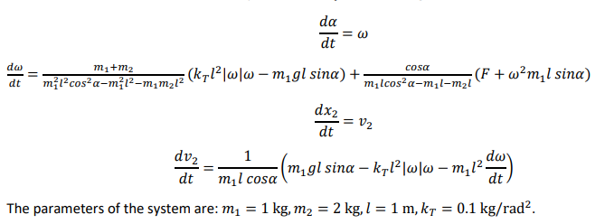
and translating them into a linear model
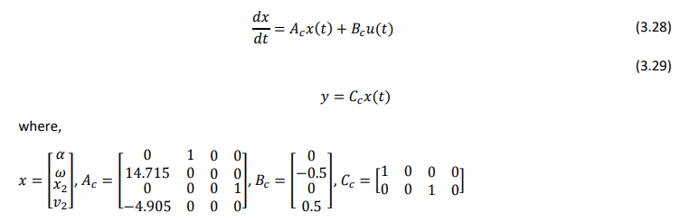
it is possible to use LQ to solve the simulation in Simulink.
The LQ problem can be formulated as a minimization problem
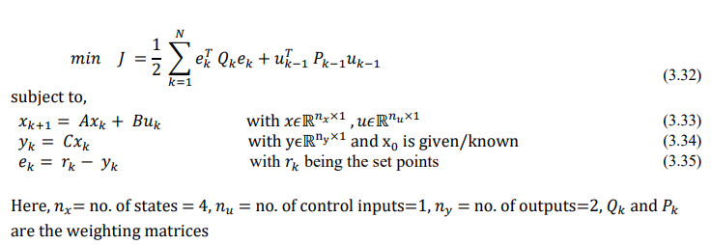
$Q=\left[\begin{matrix}1 & 0 \\ 0 & 1\end{matrix}\right]$ and $P=[0.001]$
However, to use qpOASES the problem must be formulated on standard form
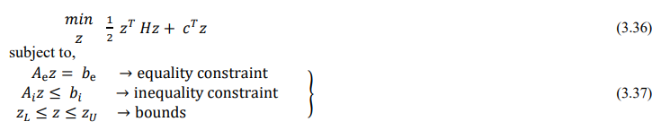
From this we get the following matrices and vectors.
$$z= \left[\begin{matrix}u \\ x \\ e \\ y\end{matrix}\right]$$
$$H= \left[\begin{matrix}I_{N}⊗P & 0 & 0 & 0 \\ 0 & I_{N}⊗0_{N*n_{x}} & 0 & 0 \\ 0 & 0 & I_{N}⊗Q & 0 \\ 0 & 0 & 0 & I_{N}⊗0_{N*n_{y}}\end{matrix}\right]$$
$$c= 0_{n_{z}, 1}$$
$$A_{ϵ}= \left[\begin{matrix}I_{N}⊗-B & I_{N,n_{x}}-(I_{N, -1}⊗A & 0_{N*n_{x},N*n_{y} } & 0_{N*n_{x},N*n_{y} } \\ 0_{N*n_{y},N*n_{u} } & I_{N}⊗-C & 0_{N*n_{y},N*n_{y} } & I_{N*n_{y}} \\ 0_{N*n_{y},N*n_{u} } & 0_{N*n_{y},N*n_{x} } & I_{N*n_{y}} & I_{N*n_{y}}\end{matrix}\right]$$
$$b= \left[\begin{matrix}A*x_{0} \\ 0_{\left(N-2\right)*n_{x}, 1} \end{matrix}\right]$$
$$x_{0}= \left[\begin{matrix}0 \\ 0 \\ 0 \\ 0\end{matrix}\right]$$
We also needed the upper and lower bounds of the z vector, which are assumed to be all numbers.
$$z_{upper}= ∞_{n_{z},1},z_{lower}= {-∞}_{n_{z},1}$$
The MATLAB function for setting this up in Simulink can be seen underneath.

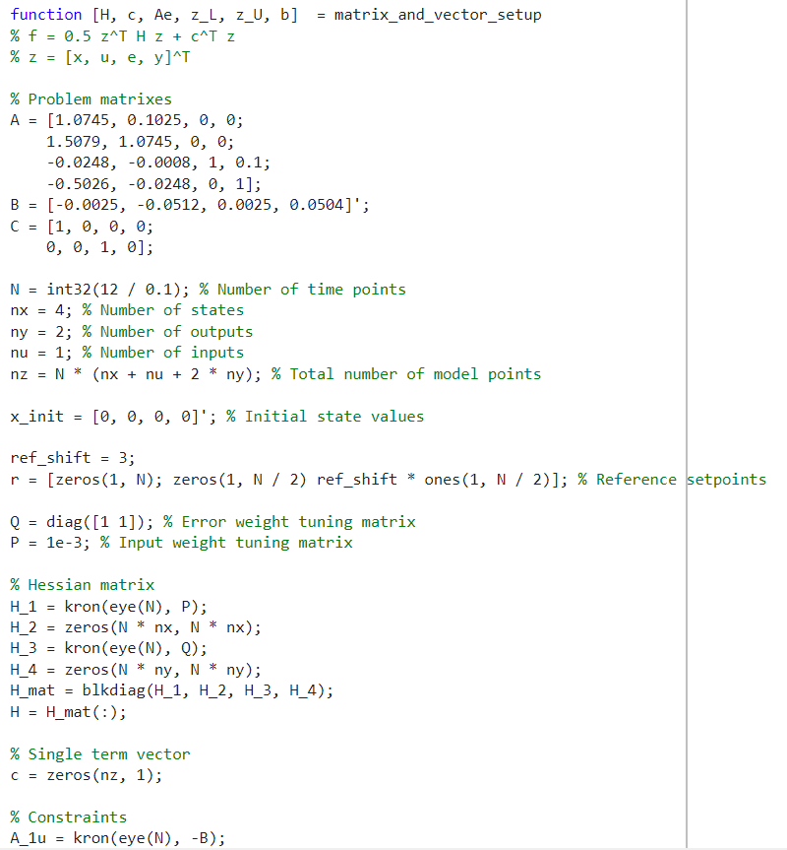
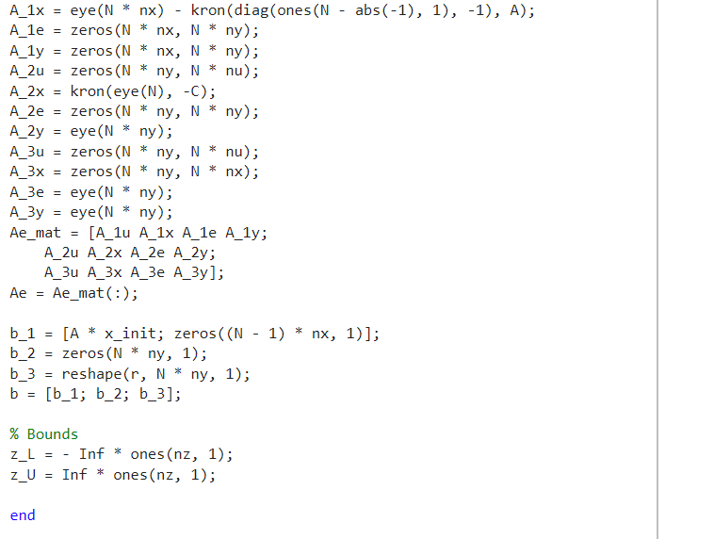
To solve the actual problem, the solver qpOASES was used with a sampling time of 0.1, 1080 input controls, 500 as max iterations and semidef Hessian type. The implementation before the compilation can be seen here: 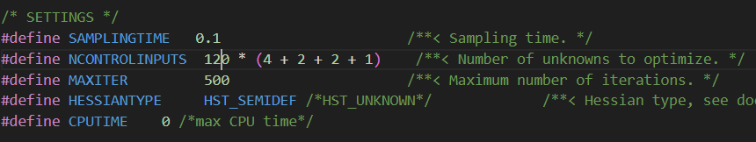
The outputs of the MATLAB function where connected to the inputs of the solver and the output of the solver to an extraction function which splits up the result array into its parts as seen here
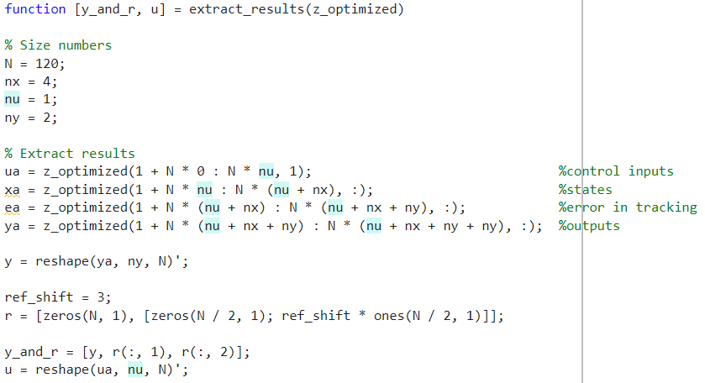
The extraction functions output is connected to an array plot each for visualisation. The resulting simulation model can be seen underneath.
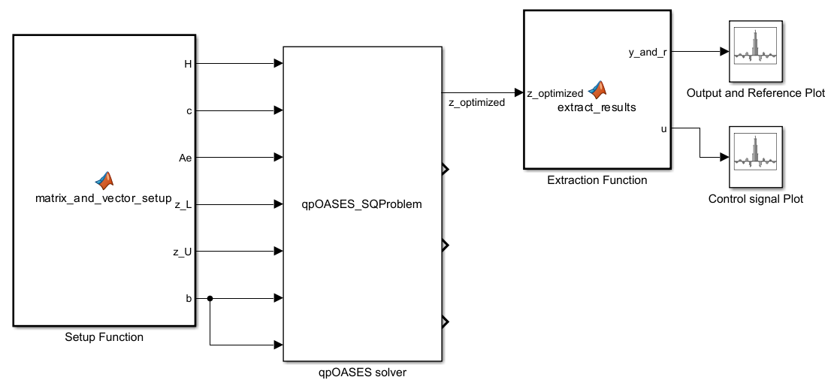
Then the simulation was run with a fixed step of 0.1, using the Runge Kutta 4 method, and a stop time of 0.1 since the solution is only calculated once. Result plots can be seen here:
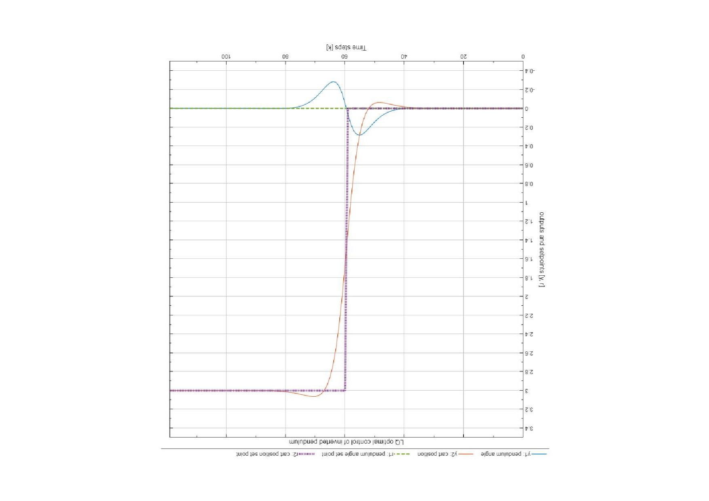
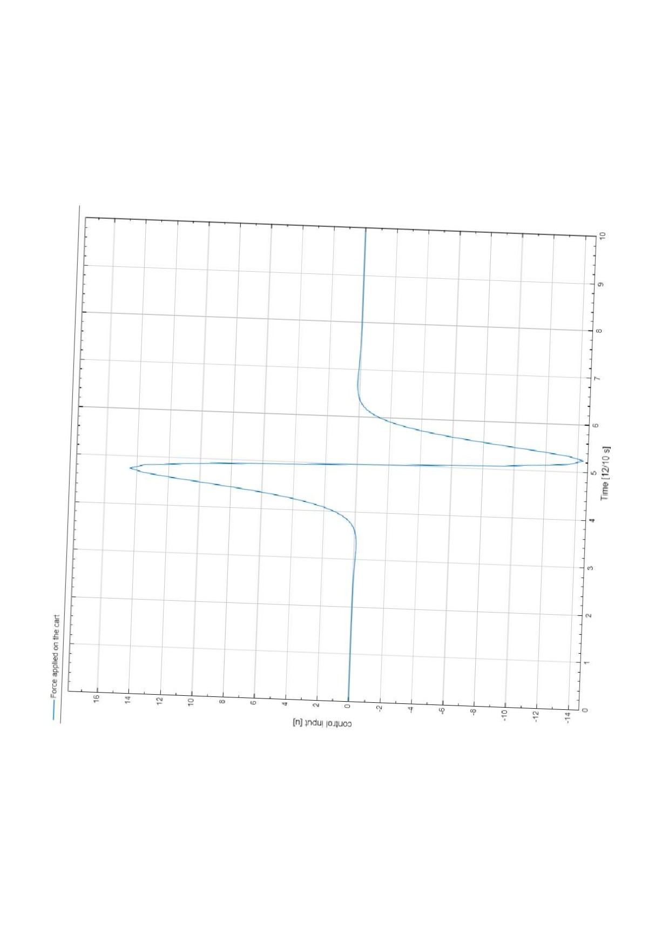
From the output plot, the step in reference point for the cart is seen as the purple line, and the green line is the unchanging reference point of the pendulum angle. The simulation results show that the cart starts by moving a little back, then shoots forward a little to much and is dragged back into its intended place. The movement of the pendulum from this is logically that it is increased when the car moves backwards. Halts and decreases when the cart moves forward and retakes it. And flattens out as the cart is moved back and stabilizes underneath it.
The control input plot shows in what way the force would have been applied on the cart. First, the cart is pulled back a tiny fraction, then it is pushed forward a lot. Then it is pulled backwards equally much, and finally it is pushed a tiny bit forward again. This logically follows the same pattern as movement of the cart in the output plot.

